English IV – British Literature
Edmond Santa Fe High School

Instructor: Ms. Allison Brackman
Room: 137
Plan time: 10:05 – 10:55 a.m.

Email: Allison.Brackman@edmondschools.net
Voice mail: 405-726-7418
Teaching hours: 7:40 a.m. to 3:30 p.m.
Textbook: McDougal Littell Literature: British Literature, Oklahoma, 2008

English IV Course Description – Edmond Public Schools
English IV is a year-long course designed to prepare seniors for the rigor and depth of college-level reading, writing, research, and oral communication requirements. Students synthesize and refine the skills that have been developed in previous English classes: reading expansively to make connections across texts, evaluating authors’ biases and purposes, and analyzing works of historical and literary significance to determine their themes, purposes, and rhetorical features. Students write for a variety of purposes in preparation for college, including application essays, expository analysis of nonfiction, and interpretative literary analysis. They continue to build writing skills through process draft writing,
grammar review, and vocabulary improvement. The course provides challenging reading of many genres – both fiction and nonfiction – and from works ranging from classical through contemporary literature. In classroom discussions, students confront conflicting points of view and learn to become more articulate speakers and more critical listeners.

In this course, we will address these four essential questions:
- How does the past influence the present?
- What is an individual’s place in the universe? How does what we do affect the natural order? What differences do our choices make?
- Where does humanity end and madness begin? How do humans overcome a personal or societal tragedy?
- Which is worse: mind control or physical control? In what ways are they alike and/or different? If you don’t have a voice, who makes humanity’s choices?

Reading will be emphasized, followed by in-depth class discussion with emphasis on listening and note taking. Students will participate in close reading exercises, writing exercises in all modes (persuasive, expository, descriptive and narrative), creative writing, vocabulary study, in-class essays, and independent and group interdisciplinary research projects.

A complete list of the Oklahoma Academic Standards is available at http://ok.gov/sde/oklahoma-academic-standards#Standards

Curriculum overview:
Skills and literary works covered may include but are not limited to the following:

- career research
- college application essays
- resume/cover letter
- Frankenstein
- Anglo-Saxon poetry
- Beowulf
- epic conventions
- development of the English language
- The Canterbury Tales
- Medieval ballads
- ballad conventions
- Sir Gawain and the Green Knight
- Hamlet or Macbeth
- elements of tragedy
- Renaissance sonnets
- poetry
- argumentation
- 1984
- grammar/usage
- ACT review/preparation
- vocabulary
- How to Read Literature Like a Professor (Foster)
- literary devices and analysis

Grading overview:
Daily Work/Homework = 35%
Tests/Essays/Projects = 45%
Semester Exam = 20%
Check Infinite Campus/Parent Portal frequently for updated grades. Please note: a blank in the grade book doesn’t indicate a zero or missing assignment; it simply means a grade hasn’t been given for that particular assignment.

Late work
Late work will be accepted for reduced credit, but will not be accepted once work has been returned or if the unit is complete. Please understand late work loses priority in grading. Any late or missing work may be discussed before or after school or during PACK time. Turn in all late work to the appropriate make-up/late work folder.

Make-up work
It is the student’s responsibility to inquire regarding make-up work. In accordance with the Santa Fe High School Student Handbook, students have one school day, plus one day, to make up work for each day absent. Work assigned prior to a planned absence is to be turned in on the original due date or the day of return from the absence; however, if new instruction takes place during the absence that would affect an assignment, the student has one extra day to make up the work.

Leaving class
Leaving class is up to the teacher’s discretion. Per ESFHS school-wide procedure, students may not leave within the first ten minutes, the last ten minutes, or in the middle of instruction or reading. Students must have a green pass to leave the classroom and must sign out and back in on the specified sign out/in log (as required by ESFHS administration). Only one student may be out of the classroom at a time.

Smart classroom behavior – PROTECT the PACK
Be here; don’t miss class unnecessarily. Be on time. Participation is a requirement; be prepared to engage. Be respectful at all times; do not talk while the teacher is talking, while another student is talking or while announcements are being made. Choose your words carefully. Stay awake. Do not congregate in the doorway while awaiting the bell prior to or upon the conclusion of class. Food must not be a distraction. Any drinks brought into the classroom must have lids. If trash is left in the classroom, food and drink privileges will be revoked.
Practice respect.
Accept responsibility.
Commit to excellence.
Keep it classy.

Electronic devices/phones
During class, your cell phone is to be placed out of site and silenced; this includes disabling flashing notifications and vibrations. Cell phones and other electronic devices may not be used unless otherwise advised. Answering your phone during class is not acceptable. It is recommended that students have access to ear buds or headphones in case use is allowed; however, ear buds and headphones are not to be visible when not permitted for use. If a student refuses to silence or discontinue use of a cell phone or other electronic device, it may be confiscated and given to an administrator, per district policy.

Academic dishonesty
Do not cheat. If a student is caught cheating during a quiz or using the work of another student to complete an assignment, all students involved will receive a zero. Do not photograph tests, quizzes or other class assignments and distribute to other students. Do not use photographed tests, quizzes or other class assignments to complete your own work – even if for another class. If caught photographing work with the intent to distribute, or using photographed work, an administrator will determine your fate.

Items needed for this class – bring to class every day
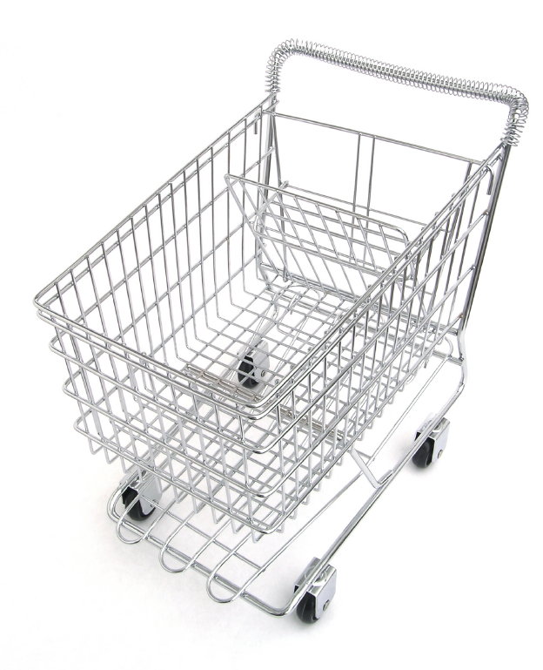
- student-chosen method to organize classwork (binder, folder, etc.)
- notebook paper
- pencils
- blue or black pens
- red pen (for editing)

- Post-It® notes
- box of 16 or 24 crayons
- five, differently-colored highlighters
- index cards – 3 in. x 5 in. or 4 in. x 6 in.

Supplemental materials
How to Read Literature Like A Professor, Thomas C. Foster, 2003
ACT released exams
Novels, plays, essays, short stories, etc., including, but not limited to:

Frankenstein (novel and films)
Hamlet and/or Macbeth (play and films)
Beowulf (story and films)
1984 (novel and film
Appropriate and applicable resources from EPS libraries
Appropriate and applicable online resources, including, but not limited to:
United Streaming/Discovery Learning
YouTube
TED

ACT exam dates
September 12, October 24 and December 12, 2015, and February 6, April 9 and June 11, 2016
http://www.actstudent.org

Please sign and cut off this portion of the syllabus and return with the requested information and your signatures by Monday, August 24. This is your first grade in English IV.
Parents/guardians and students:

STUDENT NAME: ________________________________________________ HOUR: ________________
We have read this English IV syllabus and understand the classroom procedures and norms as aforementioned.

Frequently checked parent/guardian email address: _____________________________________________
________________________________________________ (student) ________________(date)
________________________________________________ (parent/guardian) ________________(date)

